**Report on voltage fluctuations and how the battery percentage should be measured**

# Battery percentage measurement without the motors running

An input related to the battery level can be taken from the I/O pin 1. Using analogRead() we can measure the values.

|  |  |
| --- | --- |
| Value from the analogRead() = X | Voltage of the battery = Y |
| 1226 | 3.81 |
| 1242 | 3.87 |
| 1260 | 3.92 |
| 1275 | 3.97 |
| 1355 | 4.22 |

These data have a Pearson correlation of 0.999746. Hence these data are highly corelated.

Y = -0.04828 + 3.15058*(10^-3)X

Readings can be mapped out to real voltages using this equation.

# Battery percentage measurement when the motors are running

When the motors are running a noise is generated in the reading.

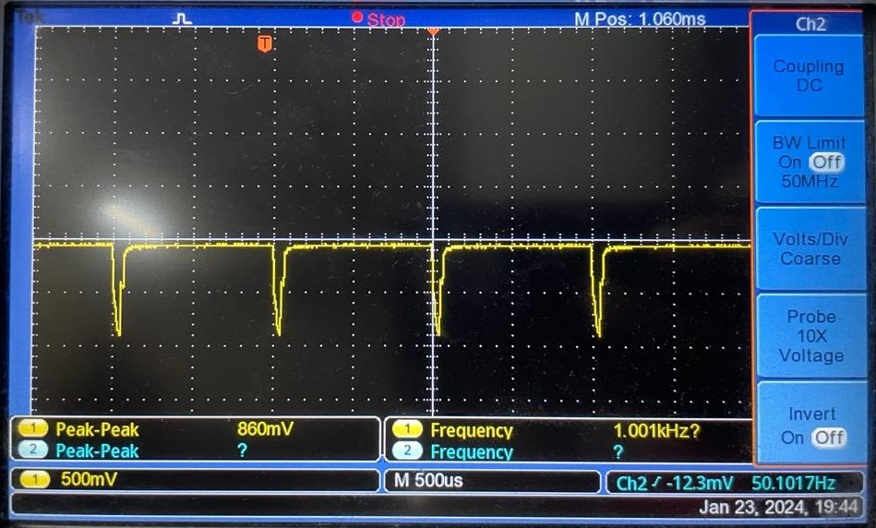

A periodic wave with a frequency of 1kHz is formed. This noise can be filtered by using a LPF with a cutoff frequency less than 1kHz.

When the motors start running a sudden voltage drop is occurred in the reading.

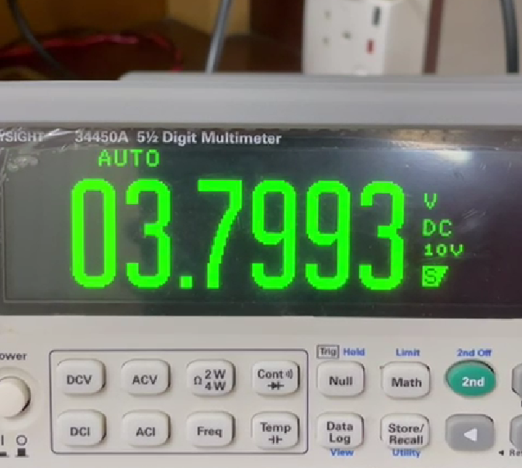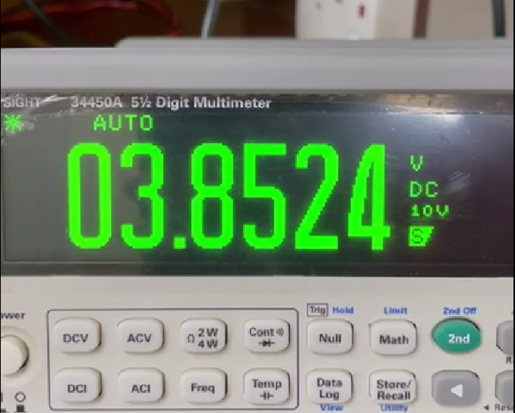

**(Before motors run) (When motors are running)**

This drop varies with the real battery voltage (voltage before the motor runs).